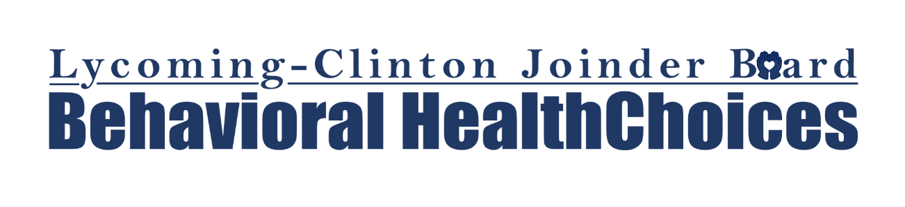

Family Engagement Improvement Initiative
Low parent and family participation rates in behavioral health services for children and families reduces the impact of treatment and the potential for positive treatment outcomes, as well as increases the costs of program delivery, making evidence-based treatment and family focused services critically unsustainable for smaller, rural communities. Financial incentives can help families faced with situational barriers, Social Determinant of Health needs, or competing demands; can reduce obstacles to treatment participation, and serve as positive reinforcement during what can be a difficult therapeutic process.

Research regarding incentivizing family engagement indicates that offering incentives such as gift cards in conjunction with interventions found to produce long-term impact on engagement and retention (creating and sustaining a therapeutic alliance over the course of treatment; ensuring choice in the direction of treatment and goals; managing expectations related to progress and perceptions of therapy; and positioning families as partners in the therapeutic process) improved completion of family “homework assignments” and paperwork, increased appointment/program attendance rates, and reduced no-show rates.

Lycoming-Clinton HealthChoices is seeking to partner with our child and family service providers to improve active family engagement and retention in behavioral health services. “Active engagement” is defined for the purpose of this initiative as consistent response to provider requests for information, documents, and completion of “homework”; consistent participation in therapy and other treatment plan related activities; and/or other service activities as defined by our behavioral health providers. Providers will submit a proposal application for approval and will be allocated gift cards for distribution to families as indicated in their proposal. Providers will measure over the subsequent 12 months, the rate of change for family engagement in services following implementation of the incentive initiative. Providers may also choose to employ additional outcome measures to demonstrate treatment gains or improvements realized due to the incentive initiative.
Providers who are interested in participating in this initiative are invited to complete the proposal application. Reporting requirements will include one six-month follow-up report and one outcome report. Overall, we are projecting a 1% increase in active family engagement in services. Children and families receiving gift cards must be Lycoming-Clinton HealthChoices members residing in Lycoming or Clinton Counties.

The final number of gift cards allocated to providers will depend on the number of providers who choose to participate in the initiative. Providers will be notified of their allotment.

Implementation Timeline:
1. Application to provider network by January 18th, 2024.
2. Receive provider applications back by February 2nd ,2024.
3. Respond with approvals by February 28th , 2024
4. Purchase gift cards by March 31st , 2024
5. Target April 20th for allocation to providers “in the mail”.
6. Create outcome tracking spreadsheet and document provider reported baseline measures by March 1, 2024.
7. Distribute and collect Provider Bi-annual Report, to study results; report results back to providers and CCBH in November, 2024.
8. Distribute and collect Year End Provider Report, to study outcomes over 12 months; report results back to providers and CCBH by March 30, 2025.

