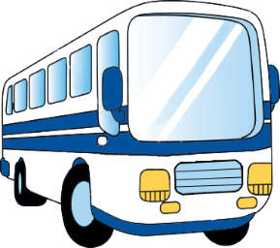
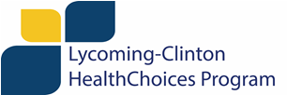

Transportation Assistance

Lycoming- Clinton HealthChoices currently has funding available to help Lycoming and Clinton County HealthChoices MA-enrolled adults, children, and families with behavioral health needs in overcoming transportation barriers to treatment and supportive services. HealthChoices will also help on a case-by-case basis for up to 6 months transportation assistance (one request granted every three months) to support employment for individuals with behavioral health needs in participating in new employee training and to travel to work.

Providers may submit a HealthChoices Transportation Request Form on behalf of a Lycoming-Clinton HealthChoices MA-enrolled client to request one River Valley Transit Bus Pass (10-ride) or one SHEETZ Gas Card ($25).

HealthChoices is not able to reimburse clients or transportation services directly. HealthChoices will reimburse providers who assist with costs related to Lycoming and Clinton County HealthChoices MA-enrolled client and family travel to treatment facilities located out of the area. Providers may submit a Health Choices Transportation Reimbursement Request Form to receive reimbursement. If reimbursement is being requested for a shared-ride service (Uber or LYFT), the reason the service was used must be clearly documented on the reimbursement form; tips are not reimbursable.

ALL client and provider transportation reimbursement requests must include information verifying client MATP eligibility status; if the client is MATP eligible but STEP Transportation options are not appropriate for the current situation, an explanation is also required for approval.

Please email all requests with a completed Funding Request form (see attached) to:

Deanna Kimble dkimble@joinder.org

